In this section, we will learn about the deployment of Kubernetes on cloud such as Google cloud, Azure cloud and AWS cloud. There are two types of solutions for Kubernetes deployment:

1. Self-hosted/Turnkey Solutions
2. Hosted Solutions (Managed Solutions)

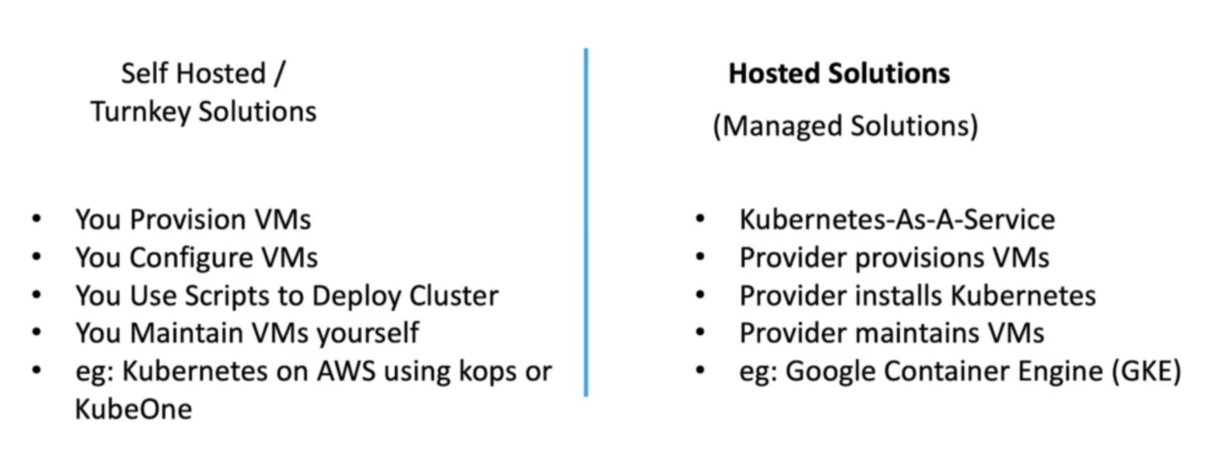

In this we will try to deploy the same application on different clouds.